**Group1**

Group 1 project team

Team Name: The Big Fit

Team Members: Serena Villacorta Yi Zhuang Seher Mumtaz Alaa Alhiadari

Project Concept: Weight Tracker

We will be building a weight tracker program that will help a person keep track of their weight. This program is perfect for those who need that extra motivation to lose weight by helping one visualize their progress.

User Stories:

As a user, I would like to be able to create an account, so that I may access the system. 3 days Priority 10

As a user, I would like to be able to log in/out, so that I may access the system. 3 days Priority 10

As a user, I would like to enter in my information such as my current weight, target weight, age, gender, height, and zip code, so that the system can have information about me. 3 days Priority 10

As a user, I would like to see the information I entered in, so that I can view my information. 5 days Priority 10

As a user, I would like to track my weight, so that can see a history of my weight. 3 days Priority 10

As a user, I would like to be able to update my information, so that I may make changes. 3 days Priority 20

As a user, I would like the ability to delete a weight entry, so that I can fix any mistakes. 3 days Priority 20

As a user, I would like to see visualizations, so that I can see my progress over time 10 days Priority 20

As a user, I would like to receive SMS messages, so that I will be reminded to enter in my weight. 3 days Priority 30

As a user, I would like a daily calorie suggestion, so that I can make healthy eating decisions. 3 days Priority 40

As a user, I would like to be able to enter my calories consumption, so that I can keep track of my calorie intake. 10 days Priority 40

As a user, I would like the ability to delete a calorie entry, so that I can fix any mistakes. 3 days Priority 40

As a user, I would like to be able to track my calories, so that I can see history of my calorie intake. 40 10 days Priority 40

As an owner, I would like to be able to visualize data aggregations, so that I might learn more about people and weight. 15 days Priority 50

Stakeholders:

Customer: People looking to lose/gain weight Health conscious people

Owner: us

Part B:

1. Decompose your user stories into tasks
   1. Create splash screen
   2. Create login screen
   3. Create logo
   4. Create backend database objects
   5. Create entry screen
   6. Create main screen
   7. Create visualizations
   8. Create weight history screen
   9. Update entry screen
   10. Create SMS messaging
   11. Incorporate calorie suggestion
   12. Daily calorie consumption entry
   13. Update/delete calorie consumption
   14. Create calorie consumption tracking screen
   15. Create visualizations for admin
2. ITERATION -1 Decompose your user stories into tasks (Oct 4 – Oct 15)

Working days: 8 Days

* 1. Create splash screen
  2. Create login screen
  3. Create logo
  4. Create backend database objects

1. ITERATION- 2 Decompose your user stories into tasks (Oct16 – Nov 8)

Working days: 18 Days

* 1. Create backend database object
  2. Create user information screen
  3. Create view information page
  4. Create update information page
  5. Create weight tracking page

1. Build the iterations (at most 2) that will compose your Milestone 1.0. Record the total days of work and the time it will take for your team to complete that work.
   1. Total days of work = 24 days (Oct 4 – Nov 8 - 1Milestone, 2 iterations)
2. Make sure you have dealt with velocity before breaking into iterations.
   1. Velocitiy – 30% or 0.3 per person

4(person) X 24(days) X 0.3(V) = 29 amount of work for 1 Milestone

1. Allocate tasks to each team member and record the allocation.
   1. Create splash screen - Alaa
   2. Create login screen - Yi
   3. Create logo - Seher
   4. Create backend database objects – Serena
2. Create a burn down chart for monitoring your team’s progress.

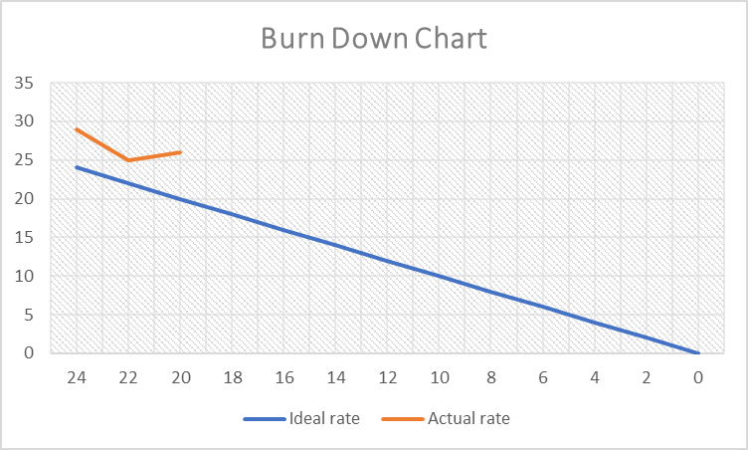

* 1. Please see "burndown chart iteration 1.png under Documents folder"

1. Create a burn down chart for monitoring your team’s progress.
   1. Please see meeting minutes under documents folder